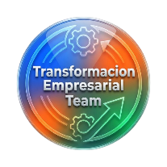
Company Name: Livegood
Pre-Registration Form


- First Name: ______________________________________ Back Office Registracion
- Last Name: ______________________________________
- Email: ___________________________________________
- Phone Number: ( ) _________ _____________
- Username: ______________________________________
- Password: _______________________________________
- Sponsor Username: ______________________________
- Address: ________________________________________________________________________
Packages
☐ Customer Only ☐ Package 2 $9.95 plus $40 ☐ Package 3 $99.95 plus $40 = $139.95
$9.95 Monthly $9.95 Monthly Full year
Payment Information
- Card Method (Visa/Mastercard/Amex/Other): ___________________________
- Card Holder Name: __________________________________________
- Card Address: ____________________________________________________________
Consent for the Use of Data and Debit Card
NOTE: This tool is not provided by LiveGood. It is a resource created by Transformación Empresarial Team
to help speed up the registration process and offer support.
By providing your data, you authorize:
- Use and Access: Your information may be used solely to process your registration and allow authorized support personnel to assist you.
- Transparent Handling: Your data will be treated with integrity and used only for registration and support purposes.
- Prohibition of Misuse: Any attempt to alter or misuse this platform is forbidden. Any violation will result in immediate suspension from our team.
- Limit of Liability: Transformación Empresarial Team is responsible only for guidance during registration. We are not responsible for misuse of information outside these terms.
I Agree: X _______________________________________ Date: ____ / ____/______

